The Ozone Generator “Ozone DTA “©

Prof. Dr. sc. med. H. - G. Schneider / Berlin

1. The multifactor mode of action

Using a high voltage the device converts a noble gas mixture (argon / helium) into a plasma which emits an electro-magnetic field.

The gas mixture is located in glass bulbs of different forms (spherical, plate, cylinder, specially formed ), which takes up the high voltage out of the hand piece over electrodes and builds up the electromagnetic field according to the rhythm of the current frequency.

The energy of the electro-magnetic field on the surface of the glass bulbs, which one designates plasma lamps, converts part the oxygen in the air into ozone according to the equation  
O2 ^ 2 Oi + 2 O2 ^ 2 O3. The atomic oxygen ( Oi ) is carried as a gas in the form of ozone (just like the air) into all skin or wound cracks and reacts there with the germs in the lipoproteins of the cell membranes (bacteria, viruses or fungal spores).

This reaction takes place within 10-4 seconds ( 1/10000 th of a second). The germs do not have defence options within this reaction time, for enzymatic change of the plasma metabolism or genetic mutations, that is building up any resistance. Destruction of the cell membrane causes perforations through which the cytoplasm leaks out of the germs and they can no longer survive. The ozone locally converts again into molecular oxygen according to formula 2 O3 ^ 3 O2 as soon as the ozone does not find a “target ". This oxygen promotes the local metabolism and supports the activity of the scavenger system [1].

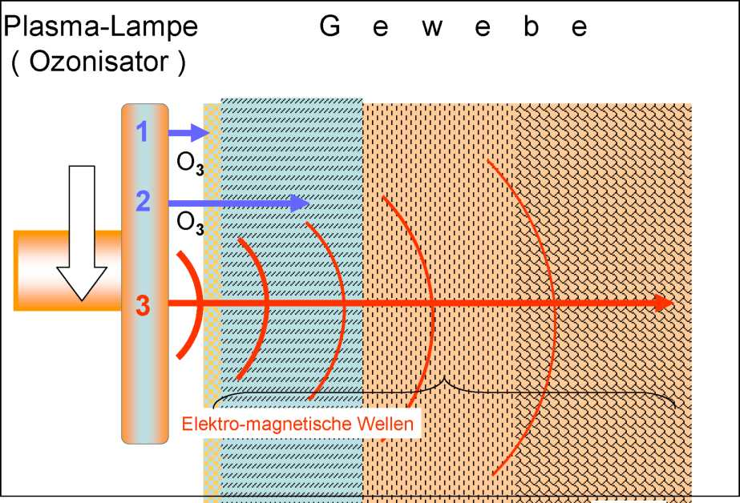

Figure 1: Influencing factors of the generator “Ozone DTA"

Factor 1 + 2 = ozone, Factor 3 = electro-magnetic field

Plasma lamp T i s s u e

Ozonisator

Electro-magnetic waves

Factor 1 Killing of bacteria by ozone in biofilms

as a result of cell membrane perforation and plasma loss

Factor 2 Diffusion of O3 into the tissue: destruction of the germs which have been

infiltrated, splitting of the toxins through the reaction

O3 ^ Oi + O2; enrichment with oxygen occurs

Increasing the venous stasis + removal of acidosis

Factor 3 Stimulation of the tissue by an electro-magnetic field. Stimulation of local metabolism incl. the scavenger system***.

*** Explanation : The modern term “scavenger” include all elements of the body’s own immune system both corpuscular, immunological and enzymatic.

According to the definition given in the “Oxford dictionary", the term includes self-cleaning of nature by living organisms which feed on dead animals or plants (for example: vultures, jackals, hyenas, rotting of leaves by bacteria ) or from excrements (for example: dung beetles, faecal microflora amongst others) .

|  |  |  |
| --- | --- | --- |
| Local effects of ozone ( O3 )  Externally, internally on | | |
| Bacteria | Enzymes | |
| Viruses | Macrophages | |
| Micro-fungus – spores | Erythrocytes | |
| Aromatic substances | Capillaries | |
| Organic pigments | S | Macrophages |
|  | | Enzymes |

2. Local external effects

on bacteria, viruses, fungus spores, organic aromatic substances and pigments

The effect of the ozone and, furthermore, all other peroxides is based upon splitting of a part of the oxygen in the air ( = molecular oxygen / O2 ) into atomic oxygen (X O1 ).

An electron in the atomic shell is brought into an orbit at a higher energy level by the energy of an electro-magnetic field and alters its spin in the process, that is the rotation around itself, as well as the direction of rotation in orbit around the nucleus of the atom ( see figures 2, 3 and 4 ).

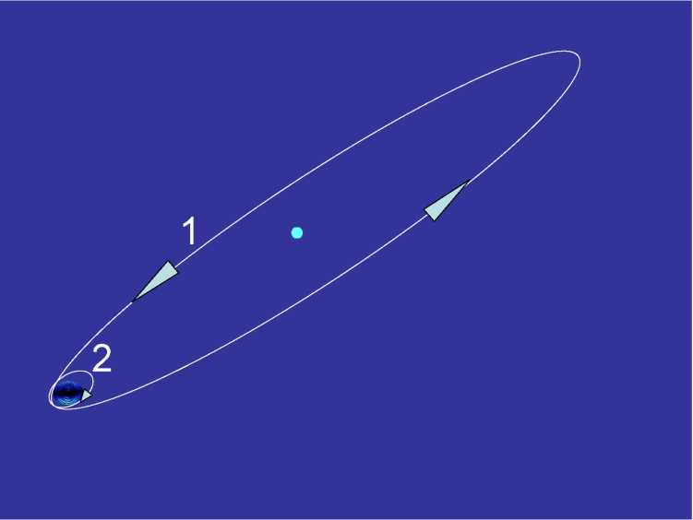

Figure 2: Orbit of an electron around the nucleus of the atom (1) and rotation of the electron around its own axis = spin ( 2 ).

The next figure shows the changes in the electron orbit and the spin due to the addition of energy from the electro-magnetic field.

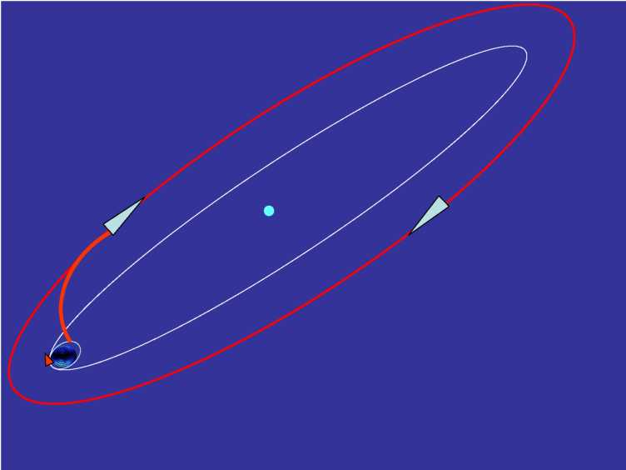

Figure 3: The electron is brought into an orbit at a higher energy level by the added energy and changes both the direction of orbit around the nucleus of the atom as well around itself = spin ( see also additional Figure 4).

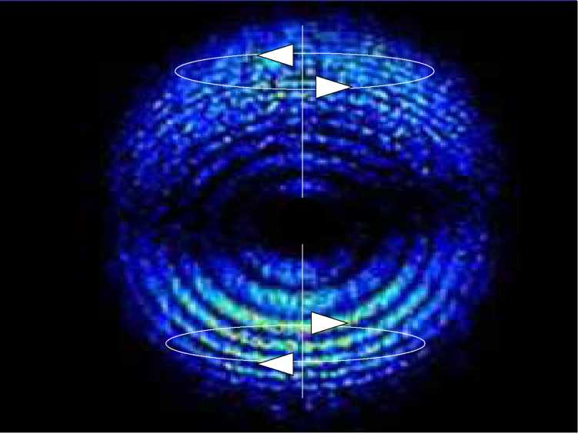

Figure 4: Change of spin by an electron through addition of energy.

Above: normal spin. Below: spin in the opposite direction.

Figure 4 is a sensational picture which was taken on 25.02.2008 at University of Lund. The sensation comes from the fact that every electron orbits around the nucleus of its atom in an atomic second (10-18 sec), that is 1,000,000,000,000,000,000 times per second). This proves that our material world primarily consists of electrical fields and not matter.

4

The complicated process which have been described for splitting of the oxygen molecules into oxygen atoms (oxygen in statu nascendi ) represents an energy transfer from an electromagnetic field from the plasma ­lamp (the “Ozone DTA" generator) to the oxygen atoms.

The oxygen atoms are extremely reactive, reacting, as mentioned above, with neighbouring oxygen molecules in a period of just 1/10000th of a second and thus producing an ozone molecule ( O2 + O1 ^ O3 ), which carries the energy of the plasma lamp within itself ( see Figure 5 ).

|  |  |  |
| --- | --- | --- |
| Oxygen in | O1 | atomic |
| statu nascendi | Oxygen mono - oxygenium |
| O2 + O1 | | O3 |
| molecular  oxygen |  | Ozone |
| Di - oxygenium |  | Tri - oxygenium |

Figure 5: Transfer of electrons from atomic oxygen to ozone (see the red point which is normally marked black in as far as this point is not generally let away since the high reactivity of O1, H2O2, BaO2, Na2O2 and others is known.

The electron charged with energy it not only extremely reactive but is, in a gaseous form, also extremely diffusible. The ozone finds its way into the tiniest cracks, lesions, wound and abscess cracks. The ozone diffuses particularly well into aqueous media (secretion, intercellular substance, blood plasma amongst others) and, in this way, achieves a high depth of permeation into the body tissue (see later:

1. Local internal (effects)

The energy of the electron, stored in the ozone, explosively destroys the double carbon bridges in the organic structures, in particular in the lipoproteins of the cell membranes. This, on the one hand, explains the bactericide and virucide effect of ozone and, on the other hand, the deodorising and bleaching effect.

**-C = C - 0**1

Figure 6: Explosive destruction of the organic double carbon bridges by atomic oxygen ( O1 ), shown in the picture as a small atom explosion.

Destruction of the cell membranes of the bacteria leads to perforations through which the cell plasma is emptied out and thus the damaged cell dies.

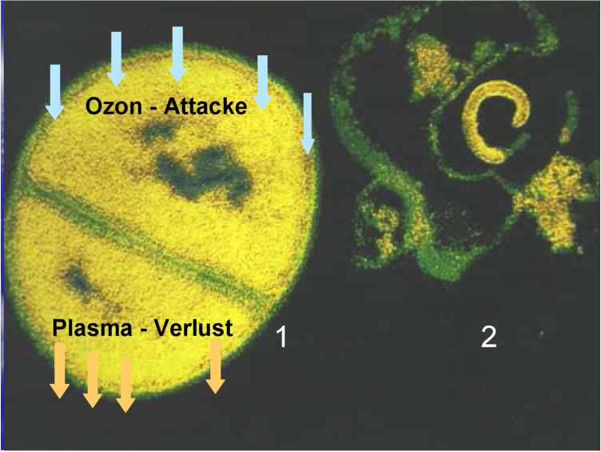

Ozone attacks

Plasma loss

Figure 7 :

1= A cell in the process of splitting,   
above: impact of atomic oxygen in the cell membrane due to the effect of ozone,   
below: plasma streams out of the body of the cell (both processes schematised).

2 = Cells killed by ozone

Cadaverine H H H H H H H N C C C C C N H H H H H H H

Pentamethylenamine

Figure 8: Structural formula of the organic aromatic substance cadaverine. The name gives away its natural origin.

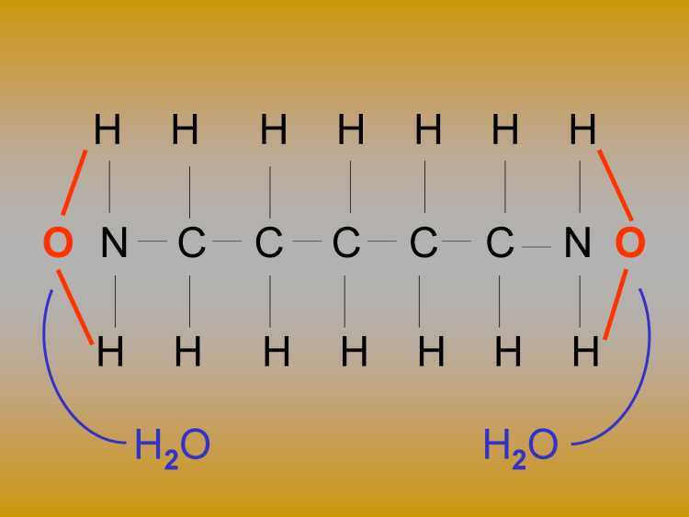

Figure 9: Oxidative destruction of the cadaverine by atomic oxygen (the reaction marked in red) and production of water (the reaction marked in blue). The molecule remaining does not smell as penetrant.

The ozone also attacks organic dyestuffs which have a double carbon bond in the middle of the molecule (see red arrow). This means R1 + R2 alkyl radical and X+ Y substituted alkyl radical (according to the dyestuff in its different form)

R> -0-N==<X

This reaction takes place when bleaching hair and teeth.

The significant point is the fact that ozone always creates a dipole and can therefore dock both at negatively and positively charged interfaces. In contrast to cells of the eukaryotes, which can alter their membrane potential, prokaryotes such as bacteria and viruses do not have this ability

- they are always negatively charged.

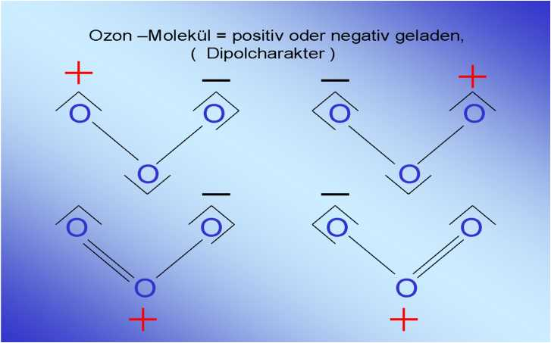

Ozone molecule = positively or negatively charged   
(dipolar character)

Figure 9: Valency structure of the ozones   
2. Local internal effects of ozone   
2.1 Removal of intra-cellular created H202

The macrophages (scavenger cells, killer cells) are capable of locking onto bacteria in infected, inflamed tissue and to phygocytise, as shown below in figures 10 and 11.

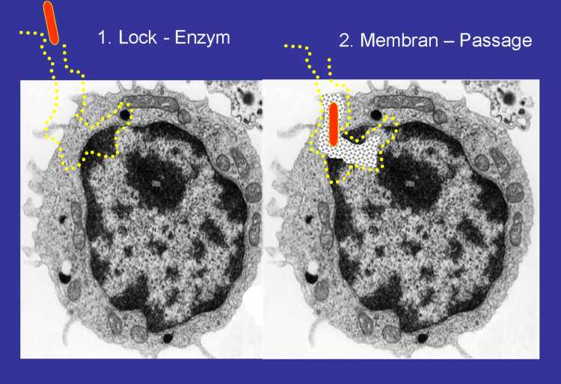

Figure 10: First phase of the phagocytosis

1 Lock – enzyme 2. Membrane - passage

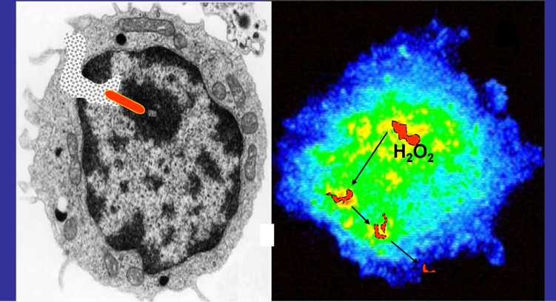

Figure 11: Destruction of the bacteria by intracellular formed hydrogen peroxide ( H2O2 )

The hydrogen peroxide which is not used to kill germs represents a cell poison for the macrophage itself and must therefore be degraded using enzymes (see Figure 12).

3. Vakuolen - Einschluss 4. Oxydative Zersetzung der

Bakterie

|  |  |  |
| --- | --- | --- |
| Unused O | 2 |  |
| from the respiratory chain | |  |
| ▼ |  |  |
| Superoxide radical 4 x O | 2 x O2 |  |
| Superoxide dismutase^^^g^^ | S  . N | |
| / | V y | A |
| . 1 | 1 | ▼ |
| Hydrogen ions 4 x H+ | 2 x H2O2 | O2 + |
| from the citrate cycle |  | 2 x H2O  4 |
| Hydrogen peroxide produced in the macrophages V w / | | |
|  | |  |
|  | 1 Glutathione peroxidase | | |

Figure 12: Degradation of intracellular H2O2 by the enzyme catalase

Unused **O2 from the respiratory chain**

Superoxide radical 4 x O

2 x O2

**Superoxide dismutase**

**Catalase**



2

Hydrogen ions **4 x H+ from the citrate cycle**

2 x H2O2

2 x H2O

1. **Hydrogen peroxide produced in the macrophages**

**Glutathione peroxidase**

Figure 13: The ozone which has diffused into the tissue accelerates formation of the above-mentioned tissue enzyme and therefore contributes to removal of the radicals (shown with a red border).

1. **Influence of ozone on the microcirculation**

The erythrocytes lose their membrane elasticity in cases of general oxygen deficiency. This property is, however, very important for the passage of capillaries since the red blood cells must deform in order to pass through the tight lumina of the capillaries. The following Figure 14 represents this process schematically.

Pre-capillary Pre-c a p i l l a r y Post-capillary (arterial capillary / \ (venous

inflow ) sphincter / \ outflow )

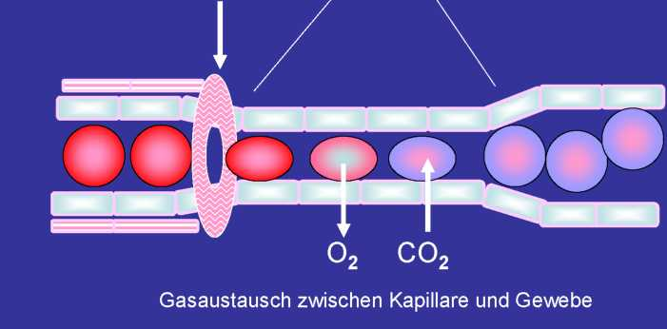

Figure 14: Small ring muscles lying before every capillary

10

Exchange of gas between the capillaries and tissue

The (pre-capillary sphincters) regulate die capillary blood circulation. If the lumina are narrow the erythrocytes must deform in order to pass through the capillaries. In a case of oxygen deficiency they lose this property through stiffening of the cell membrane (cell sleeve).

The ozone which is not used for the oxidation reactions decomposes through reversing of its formation reaction ( 3 O2 ^ 2 O3 ) into oxygen ( 2 O3 ^ 3 O2 ) and is immediately available in the tissue and the capillary plexus for cell respiration. One effect is restoration of the elasticity of the red blood cells. The blood regains its normal flow characteristics again.

Apart from any mechanical change in the erythrocytes (loss of elasticity), there is also a chemical change in the erythrocytes ­membrane due to oxygen deficiency, or more precisely a change in the membrane potential. The red blood cells which normally swim freely in the blood stream (see Figure 15), clump together and so-called rouleau formation occurs (see Figure 16). These small bodies similar to an embolus not only block up the capillaries but also the upstream pre-capillaries and promote slowing down of the blood flow speed (prestasis) up to total standstill of the flow (stasis).

The rouleau formation is reversible through increasing the oxygen concentration.

In this scheme it is immaterial whether the oxygen originates from the respiration tract or arrives through percutaneous absorption into the tissue.

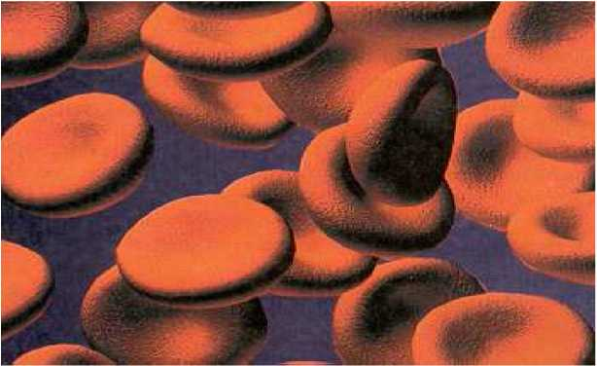

Figure 15: Erythrocytes in a normal distribution in the blood stream

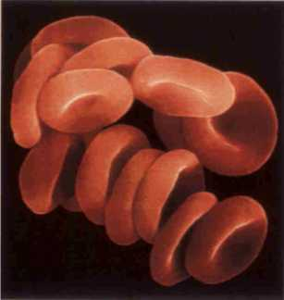

Figure 16: Clumping together of the erythrocytes due to an oxygen deficiency,

so-called rouleau formation

Influencing of the permeability of the capillary epithelium (endothelium) is closely related to the improvement in the rheological properties of the blood described above.

Fundamentally 95% of the oxygen (assuming normal respiration conditions) is transported through binding to the haemoglobin. A further supply of oxygen is dissolved in the serum and diffuses from there out into the body tissue (see Figure 17).

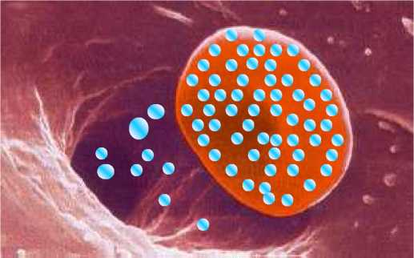

Figure 17: 95% of the oxygen transported takes place over the erythrocytes. The rest is dissolved in the serum -> also for an excess supply of oxygen, for example due to additional artificial respiration or transcutaneous infeed, for example ozone diffusion into the body tissue.

As shown schematically in Figure 14, the oxygen passes out of the red blood cells and/or the blood serum to the capillary wall in order to pass to the body tissue. Here the approx. 1 pm thick epithelial cells are the first beneficiaries of the oxygen.

Therefore an oxygen deficiency is first noticeable at the capillary wall in that the plasma of the cells swells up and thus the diffusion path increases. Damage to the intercellular substance causes the capillary wall to become more permeable for the blood plasma (so-called liquor diapedesis).

Clinically this swelling of the body tissues expresses itself as oedema.

As can be seen in Figure 18, the diffusion conditions get worse and worse, step by step, because the active movable white blood cells and later also the passively driven (relatively rigid) red blood cells in the blood stream can be found in the body tissue as the epithelium damage increases. This manifests itself clinically as changes such formation of puss or bleeding.

The unused ozone can (as described above) relieve or remove the local oxygen deficiency.

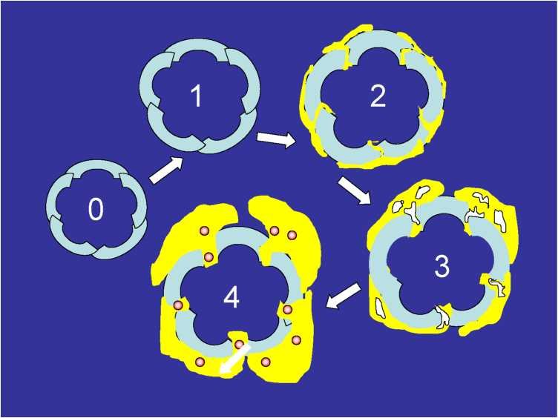

Figure 18: Stepwise destruction of the permeability at the

capillary walls due to an oxygen deficit (see series of arrows)

The decrease from 4 ^3 ^ 2 ^ 1 ^ 0 takes place for transcutaneous diffusion of O2 / O3.

Explanation: 0 = Cross-section though a capillary; blood column not shown

1. = Swelling of the epithelium cells of the vascular wall
2. = Discharge of the liquid component of the blood (serum)..

Pathological term: liquor diapedesis, clinically: oedema

1. = Discharge of the active movable blood cells (leukocytes)

Pathological term: leuco diapedesis, clinically: puss  
4 = Discharge of the passively driven components in the blood ( erythrocytes)

Pathological term: erythro diapedesis, clinically: bleeding

Figure 19 illustrates that the diffusion conditions of the capillaries to the cells of the tissue have deteriorated due to swelling of the capillary endothelium. The solid arrows (white) point towards normal diffusion conditions while the arrows with a border point towards disturbed diffusion conditions. The exit of serum has pushed the cells away from the capillaries and has therefore deteriorated its metabolism situation.

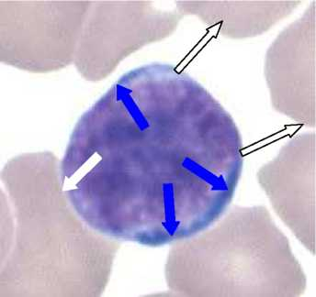

Figure 19: Cross-section through a capillary whose endothelium layer (the blue directional arrows) is partially thickened by depositing of liquor (oedema). The liquor diapedesis has pushed the cells apart and, in part, from the capillaries. The solid white arrows point towards normal diffusion conditions while the arrows with a border point towards disturbed diffusion conditions.

1. Ozone – a natural substance or a poison ?
2. 1 Ozone - the protective sheath for life on our planet

The sun continuously emits and radiates out ultraviolet light at a high intensity into space. When this radiation meets the atmosphere around our planet oxygen molecules split, as described above, and form ozone. This ozone absorbs the UV radiation and only allows a small part to reach the surface of the earth. The ozone layer is the first prerequisite for life on earth. The mass of this “protective gas" is estimated to be 5 billion tons. About 300,000 tons more are created every day and about the same amount disintegrate through chemical instability of the ozone, thus maintaining a natural balance which is, however, destroyed through human action through use of fluorinated hydrocarbons / CFCs ) as a spray propellant. The debates about the ever larger “hole in the ozone layer“ over the South Pole are adequately well-known.

One additional quantity of ozone gas arises due to the more than 3 billion lightning flashes which occur annually in the atmosphere close to the earth. Nevertheless, the normal concentration of ozone in the earth’s atmosphere is just 0.06%. Higher ozone values occur in summer for atmospheric inversion in industrial areas and congested urban areas. Fine dust and other impurities in the air acting together form blankets of smog over large congested urban areas with the currently significant increases in ozone values (see Figure 20)

Nitrous oxide Nitrogen dioxide

Nitrous tetroxide Nitrogen monoxide

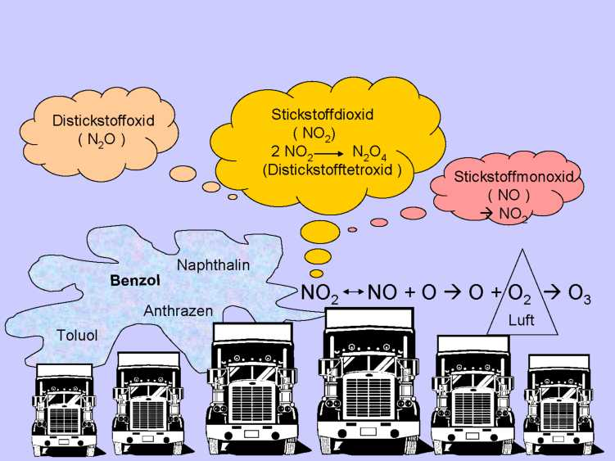

Figure 20: Occurrence of increased ozone values due to the disintegration of nitrogen oxides ( NO2 , NO + N2O4 ) and reaction with the oxygen ( O2 ) in the air for a smog alarm.

|  |  |
| --- | --- |
| 30 | Odour threshold ( 15 - 50 pg / m3 ) |
| 70 | Irritation of the conjunctiva |
| 100 | Headache 1 (no sport during an ozone alarm ! ) |
| 160 | Shortness of breath |
| 180 | MAK - value (Maximum Workplace Concentration for a working time of 8 hours / day) |

200

Lung damage possible

from a 30 min. period JJ_

Strong impairment of the ability to breath, difficulty in breathing, pain in the chest   
ZNS disturbances ( ^stupor )

**350 400 > 400**

Ozone in higher concentrations are damaging to the health in humans (see Figure 21).

Toxizität von Ozon in pg / m:

Figure 21: Danger to human health through permanent exposure

The maximum working concentration (MAK value) was previously a binding limit. The MAK value is currently not a legally establishment limit but is now just a recommendation.

As can be seen in the table above the damage first manifests in the lungs. The reason lies in the fine structure of the lungs. The approximately 200 million alveoli have walls just about 1 pm thick which are very sensitive to the biochemically reactive ozone (see Figure 22).

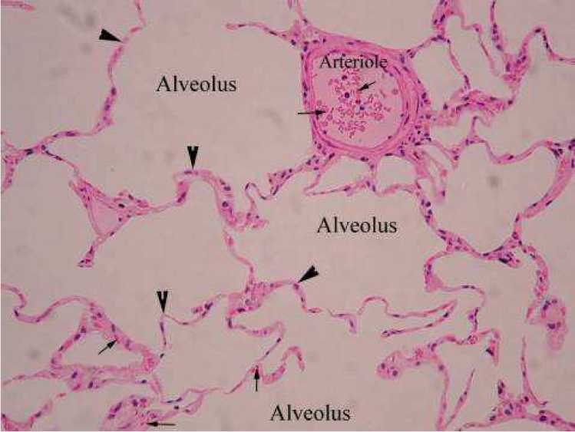

Figure 22: Fine structure of the tissue of the lungs. The arrows point towards the single layered, epithelial covering of the alveoli.

Both the skin and also the mucous membranes consist of multi-layered squamous epithelium which also has a more or less thick horny layer on the skin (see Figure 23). This horny layer represents a diffusion barrier for locally applied medicaments.

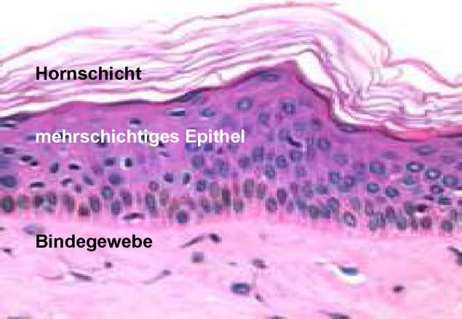

Figure 23: Cross-section through the human skin

Horny layer Multi-layered epithelium Connective tissue

If the horny layer (stratum corneum) is broken by wounds, ulcers, cracks other similar conditions

then the possibility for use of topical applications improves.

This also applies for the ozone.

1. **Working with ozone gas**

Ozone is heavier than air (density 1.65 based on air being 1.00). Therefore one should, wherever possible, place the area to be treated in such a way that the plasma probe is applied from above. The probe should not come into direct contact with the object to be treated but should rather led to it in circles at a distance of about 1 - 2 mm. Avoid direct contact because then no air will come to the plasma lamp to convert into ozone (see Figure 24).

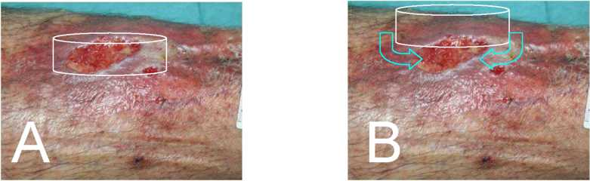

Figure 24: Wrong position of the plate-shaped plasma Lamp A.

No ozone can be created due to a lack of air as a result of pressure on the wound.

Correct distance from the wound (about 1 -2 mm) B. The air can flow in between the plasma lamp and the wound is converted into ozone (about 2 percent by volume)

One very important point for ozone insufflation concerns whether there are any diffusion barriers present in the form of biofilms, sloughing of the skin or pseudo membranes, amongst others. These should be removed mechanically as gently as possible. If ozone comes into contact with an organic substrate foam arises (more or less dependent on the catalase concentration) which should be removed by swabbing or extraction by suction.

In the case of deeper wounds it is meaningful to perform the ozone treatment before and not after sewing up to maximise the achievable depth effect.

The plasma lamps generate an ozone concentration of about 100,000 ppm – according to the new notation 100,000,000 ppb = parts per billion ). Since every gas spreads out freely into space on all sides in the shape of a sphere, whereby ozone spreads out more rapidly downwards than upwards due to the force of gravity (because it is heavier than air), one can still use the formula for calculating the spherical volume in order to calculate the spreading out of the ozone.

This formula is : VSphere = /3 x n x r which produces

^ )

r3

4.186 x r, which produces an exponential function over the radius and the power of 3 as follows:

Graphing this series of numbers produces the curve of the function: (see Figure 25 )

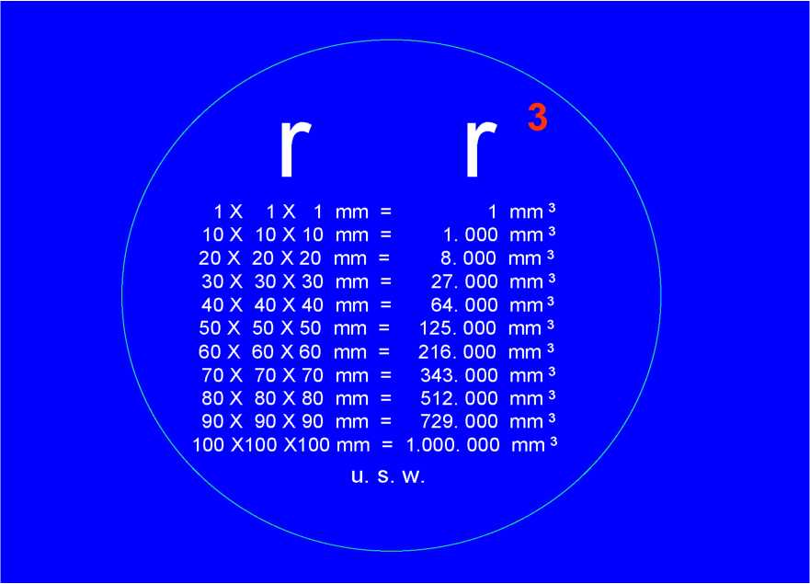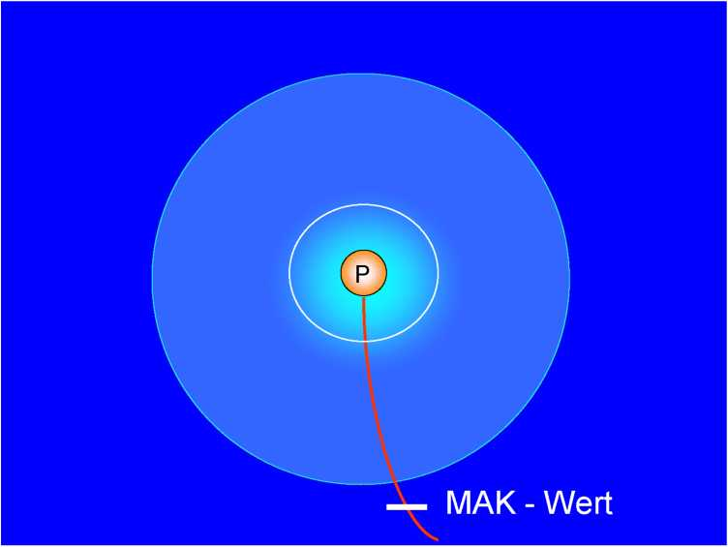

Figure 25: An ozone cloud arising from the plasma lamp P. Steep dropping off of the ozone concentration. The bactericide area (the white area) ends at a distance of about 4 mm from the plasma lamp. MAK value = danger to the health for exposure to ozone for a period 8 hours / day at a distance of about 10 mm from the plasma lamp.

One last note on handling ozone:

Ozone is very soluble in water. One should therefore wet the application area ^   
wet swabbing ^ spray ^ sprinkle ^ wash

1. Explanation : The modern term “scavenger” include all elements of the body’s own immune system both corpuscular, immunological and enzymatic.